

**2020**

|  |
| --- |
| **FM Logo** |
| **Learning Management System with Automated Assessment** |
| **Team Members:**   * Karim Hisham Mansour * Anas Hassan Gouda * Martin Fawzy Shafik * Mohamed Essam Abdelaziz * Haitham Hashim Ezzat   **Project Supervisor:** Dr. Essam Eliwa |
| **Future Academy - Higher Future Institute for Specialized Technological Studies**  **School of Computer Science** |
| Project report submitted to Future Academy for the degree of  Bachelor of Science  June 2020 |

**Team Members**

**Karim Hisham Mansour**

**Khm.karimhisham@gmail.com**

**+2 011 1739 1522**

**Anas hassan gouda**

**anashassan299@outlook.com**

**+2 010 2351 5929**

**martin fawzy shafik**

**Mf.martinfawzy@gmail.com**

**+2 012 2671 8898**

**mohamed essam abdelaziz**

**essam.lfc@gmail.com**

**+2 011 1826 1096**

**haitham hashim ezzat**

**Haitham.hashem.ezzat1997@gmail.com**

**+2 010 0471 8535**

**Acknowledgment**

First of all**,** we would like to thank Godfor being with us all the time in our long journey, we also would like to express our thanks and appreciation to our helpful supervisor   
Dr. Essam Eliwa for his patient guidance, encouragement, and advice he had provided to us all the time during the project, in addition to his dedication to his work all the time as he followed up with us in all circumstances such as quarantine, climate problems that we have faced, to see our work and progress and give us feedback.

We also would like to thank all the professors and instructors, teaching assistants who made great efforts to teach us and provide us with the learning and knowledge in order to make us ready for the labor market.

Finally, we would like to thank our institution Future Academy and all of its employees for their help and support during the four bachelor years.

**Abstract**

Nowadays the world is moving towards the automation and artificial intelligence in all institutions and organizations to facilitate their work and decrease the cost, in addition to getting the highest possible accuracy, So we have decided to build Future Marker which is a smart learning management system that can automatically mark and evaluates the programming assignments and MCQ exams, it also allows the instructors to share the course materials with the students.

Future Marker web application is one of the best solutions for the educational institutions especially the ones that are related to programming, it helps them to apply the distance education in a magnificent way as the instructor can share the materials, upload assignments, and tests his students.

This project is trying to solve various problems such as saving time and efforts for instructors who spend much time on marking and evaluating the programming assignments and multiple choices exams manually, besides the final grade, many instructors do not have the opportunity to give every student brief feedback for each one of them about their progress on the assignment submission.

We have decided to build a Java API which is responsible to assess the assignments by checking the code compilation and code indentation, feature testing, and dynamic testing, in addition, to check if the code is illustrated by comments or not, then we have decided to connect with it our learning management system which is developed by HTML, CSS, JavaScript, and Bootstrap4 for the Front-end, And for the Back-end development we have used PHP with Laravel framework in addition to MYSQL for database, furthermore, we have used MVC design pattern during our development to get clean code that facilitated our work and help us to edit or improve the system with more features now or in the future.

The project has been tested two times with the end-users (computer science) students, the first time when we finished the main API functions as have connected it with a desktop application and use it with the students while they were submitting they java project in the course of Programming language 2, and the second time when we have finished the whole system (web and mobile application) with more features like auto marking test assessment, and adding feature and dynamic testing in the API, and the result was impressive as the user was satisfied with the system performance, functionalities, and how it can make a work that was taking a lot of time from instructors, done just in a few seconds.

So Finally we can say that Future Marker smart learning management system is the best solution for all educational institutions especially the programming departments, as it allows the instructors to communicate and share materials with the students, and create coding assignments for them as it will be marked automatically and send feedback once the student submits it, furthermore the system is helping the universities and institutions to make online exams that also marked automatically when the student finishes the exam or exceeds the allowed time.

Table of Contents

Chapter1 Introduction and Background 1

Introduction 2

Problem definition 2

What is the importance of this problem? 3

What are the current solutions? 4

How will this solution solve the problem? What is new? 5

Project Description 6

Scope 6

Methodology (Proposed Approach) 6

Deliverables 7

Summary 7

Chapter 2 Analysis and Design 8

Introduction 9

User Requirements: 9

System Requirements : 10

Functional requirements : 10

Non – functional requirements: 10

Stack holders 10

System Design 10

Availability 12

Block Diagram 12

Use Case Diagram 13

Class Diagram 13

Design Patterns 14

Sequence Diagrams 16

Database Design (ERD) 16

Used Technologies and tools : 17

Summary 17

Chapter 3 Deliverables and Evaluation 18

Introduction 19

User Manual 19

Testing 24

Quality assurance will consist of several stages: 24

Evaluation (User experiment) 24

First Experiment 24

Summary 26

Chapter 4 Discussion and Conclusion 28

Introduction 29

Main Findings 29

Why is this project important? 29

Practical Implementations 30

Future Recommendation 30

Conclusion Summary 31

References 32

Table of Figures

Figure 1: Use Case Diagram 30

# Chapter1 Introduction and Background

**Main points**

* Introduction
* Problem definition
* What is the importance of this problem?
* What are the current solutions?
* How will this solution solve the problem? What is new?
* Project description
* Scope
* Methodology
* Deliverables
* Summary

## Introduction

Computer Science degrees are very popular study programs worldwide. A core topic in computer science is to learn programming skills. Programming is also related to several fields of technology, hence many university students -in various programs- study it. Novice programming students require to practice as much as possible to enhance their problem solving and programming skills. A key tool for instructors is setting assignments for students to encourage them to practice more. However, to gain the most required result from such assignments, quick and detailed feedback is required.

## Problem definition

The main problem with the traditional manual assignments marking is that the instructor usually needs to spend a lot of time and efforts to check and mark every student's code and to write a report for every student on each assignment to give feedback for the submission that informs him that his submission was good enough or not, and advise students about the mistakes that they did and what points they have missed. Instructors also need to set a clear grading policy and give students a breakdown of the grading criteria [1]. The time required to achieve this would usually mean late feedback delivery to students, it may take days and sometimes weeks for a student to know his/her marks. furthermore, the accuracy of the marking or writing feedback may decrease as the number of students increases.Also, the student can submit the assignment only once, without being able to submit it again after the feedback he receives with his grade.

## What is the importance of this problem?

By 2020 all the Educational sectors are working hard to improve themselves by using new tools and technologies or improving the old ones [2], Today we can see the importance of following up with the students as fast as possible by monitoring their level, as the instructors can evaluate them by giving them assignment and marking them, but if we are going to talk about the coding and computing we have to admit that evaluating the students by the instructor is not easy and it requires more efforts and time to check the coding level and give them a feedback for every single task, hence providing instructors with easy to use automated code assessment tool that can evaluate assignment in no time with minimum set up, and giving instant feedback to student and send a report for the instructor about each student and what grade they take and what points they miss [3], This will help student to enhance their programming skills vastly through learning from their mistakes, it will also enable instructors to set more assignments without the worry of the time they need to mark it. In addition, it will save a lot of time for the instructors and professors so that they can be more creative with their teaching with the students, furthermore now all universities and schools who don’t use or rely on an effective learning management system will suffer when any problem or epidemic happens because they will need to apply the distance education, and they can’t do this without a learning management system allow the instructors to communicate with their students and share the course materials with them, in addition to all institutions must have another alternative way to examine the students instead of the usual written exams, so they must prepare and get an online testing system so they can evaluate the students by online tests and quizzes on what they have studied from home, we can say that it becomes obvious that any educational institution are not willing to make progress in improving its distance learning mechanisms, won’t hold up in the future or when any crisis occur.

## What are the current solutions?

For many decades automatic assessment has been applied in many forms even before personal computers existed. The automatic assessment had already been suggested by Hollingsworth in 1960 [4].

In many programming courses at tertiary institutions, the use of automated assessment has been proved useful through the use of systems like:

* The Course Master Automated Assessment System (2001) [5]
* The BOSS Online Submission and Assessment System (2005) [6]
* Individualized exercises for self-assessment of programming knowledge: An evaluation of Quiz PACK (2005) [7]
* ALOHA - A Grading Tool for Semi-Automatic Assessment of Mass Programming Courses (2006) [8]
* Easy Accept: a tool to easily create, run and drive development with automated acceptance tests (2006) [9]
* PASS - Programming Assignment assessment System (2006) [10]
* Automatic marking with Sakai (2008) [11]
* Web-CAT: Automatically Grading Programming Assignments (2008) [12]
* Programming Task Packages: Peach Exchange Format (2008) [13]
* PROGTEST: An Environment for the Submission and Evaluation of Programming Assignments based on Testing Activities (2011) [14]
* A System to Grade Computer Programming Skills using Machine Learning (2014) [15]

**Course Master Automated Assessment System:**

This system is a desktop application that can mark several types of coursework in a non-trivial manner. That is, criteria can be set against which the work is thoroughly assessed. Specifically, the system is particularly good at marking computer programs, it can also mark diagrams and assist in the marking of essays [5].

**Pros:**

* Marking several programming languages
* Assisting in marking diagrams and essays
* High efficiency

**Cons:**

* Old user interface
* Used privately for a single organization
* Not multi-platform

## How will this solution solve the problem? What is new?

This project introduces Future Marker (Automated Task Assessment Cloud based System). It will reduce the effort and time consumed by instructors when they assess submitted tasks from students. It will assess tasks by using logical technique which begin with compile the code to check for runtime errors, then evaluating typographic layout which is checking for the layout and indentation, besides the identifiers’ name and length and the written comments, then checking code efficiency by running multi dynamic test cases.

Future Marker will solve many problems for students. It will allow students to submit assignments several times customized by the instructor to improve their grades and learn from their mistakes by getting instant feedback from the system.

Future Marker aims to utilize the recent technological advancement in both cloud computing and artificial intelligence to provide a smart, accessible, and easy to use system for programming instructors worldwide.

## Project Description

Future Marker is an learning management system with an automated assessment for programming assignment, the system is goal is to allow the students and instructors to interact online together, future marker allow the instructors to upload materials and assignments for the students, the system marking the programming assignment and send a brief feedback with the marks for the student, you can access the system through the web app or mobile app (IOS & Android)

## Scope

The tools and languages used to develop the system are php, java, dart, Laravel,

The project aims to deliver a great online educational system that can evaluate the programming assignments and send the feedback to the students easily.

## Methodology (Proposed Approach)

We will use agile methodology with incremental plan because it is easier to change the process to reflect changing customer requirements and the process works well when not all requirements are known.

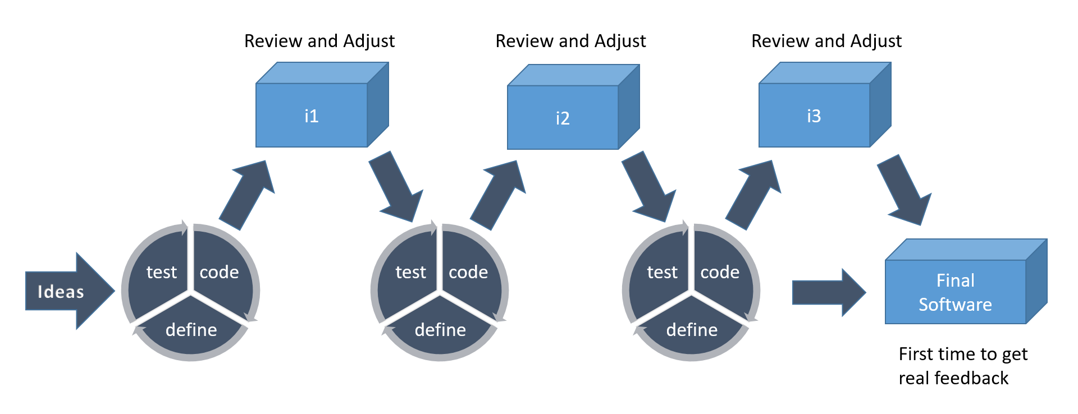

We will use scrum method because that focuses on managing iterative development, users see on-time delivery of increments and gain feedback that will help us to improve our system. We will have the flexibility to change anything while working on the system.

## Deliverables

|  |  |
| --- | --- |
| **1** | **Project Proposal** |
| **2** | **Future Marker Web application** |
| **3** | **Future Marker Mobile Application** |
| **4** | **Future Marker Documentation** |

## Summary

In this chapter we have discussed the problem that we are going and to solve and how we are going to solve it and how important it is, also we have introduced our project and mentioned the project description and it’s functionalities and what methodology we are going to use in our work, in addition to listing some of similar examples that already exist and used to solve the same problem.

# Chapter 2 Analysis and Design

**Main points**

* Introduction
* User Requirements
* System Requirements
* Functional Requirements
* Non-Functional Requirements
* Stakeholders
* System Design

## 

## Introduction

In this phase we are planning to design our system after gathering information and checking the current solutions for our problem, we have designed the diagrams and divide the whole system into functions to start working on it besides writing the user stories in the Product Backlog as we are using scrum method while working Agile, Furthermore we chose our Git hosting service and Project management software that will help us in the implementation of the project and distributing tasks, Moreover we have picked our design pattern that we are going to use during our code implementation also we have made a comparison between different web application frameworks and decided which one is going to be more suitable for our system.

## User Requirements:

1. Future Marker shall allow the instructor to create course.
2. Future Marker shall allow the student to join the course.
3. Future Marker shall allow the instructor to upload material.
4. Future Marker shall allow the instructor to create assignments.
5. Future Marker shall allow the instructor to edit assignments.
6. Future Marker shall allow the student to submit assignments.
7. Future Marker shall automate feedback to the student instantly.
8. Future Marker shall allow the instructor to create quizzes.
9. Future Marker shall allow the student to answer quizzes.
10. Future Marker shall allow the student to view assignments feedback.
11. Future Marker shall allow users to text each other.
12. Future Marker shall allow the instructor to publish posts.
13. Future Marker shall allow the student to interact with posts.

## System Requirements :

### Functional requirements :

* Instructors can create courses.
* Instructors can upload course material.
* Instructors can create assignments.
* Instructors can edit assignments.
* Instructors can create quizzes.
* Instructors can publish posts.
* Instructors can view students' grades.
* Instructors can limit permissibleattempts for assignments or quizzes.
* Students can enroll in courses.
* Students can submit assignments.
* Students can answer quizzes.
* Students can get submitted assignment's feedback.
* Students can answer an assignment within the permissible attempts.
* Students can interact with posts.
* Users can text each other.
* The system assesses programming code by running multi-test cases.
* The system sends automated feedback to students instantly.

### Non – functional requirements:

##### Security requirements:

* Future Marker not allowing the user to enter a password less than 8 characters.
* The system encrypts the passwords in the database.
* The user can’t sign in without registering on the system for one single time.
* The user can’t use existed e-mail address while registering.

##### Accessibility and Usability:

* Future Marker user interface is simple to use for any student or instructor at any age.
* You can reach Future Marker from any device connected to the internet.

##### Performance and scalability:

* The system functions work with high performance.
* The system marks the tasks and send feedback in just 3 seconds.

##### Portability:

* Future marker is a cross platform (web and mobile application).
* Future Marker mobile app supports multiple operating systems (Android and IOS).

## Stack holders

* Universities
* Instructors
* Students

## System Design

Future Marker is a 3-tier application architecture that consists of a presentation tier, an application tier, and a data tier.

* Presentation tier - This tier consists of web application and mobile application. The web application will be programmed using HTML5, cascading style sheets (CSS), bootstrap 4, and JavaScript. The mobile application will be programmed using Flutter framework to provide a mobile app for android and IOS.
* Application tier - Contains the business logic of the system. It will be programmed using PHP and Java with Laravel framework, also it will be hosted on distributed servers in the cloud. Application tier communicates with the other tiers through application program interface (API) calls.
* Data-tier – In this tier, we will use MySQL as a database for the system because it’s a relational database, secure, high performance, and on-demand scalability.

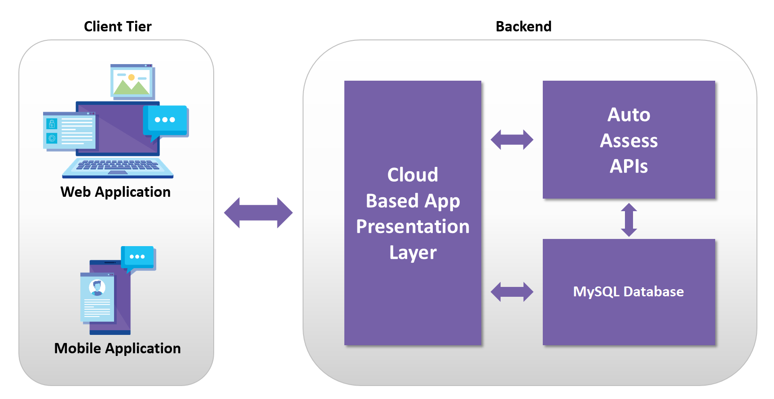

### Availability

Future Marker – Smart Learning Management System is a free software for everyone and always will be, also it can be reached from any device such as computers and smartphones at any time.

### Block Diagram

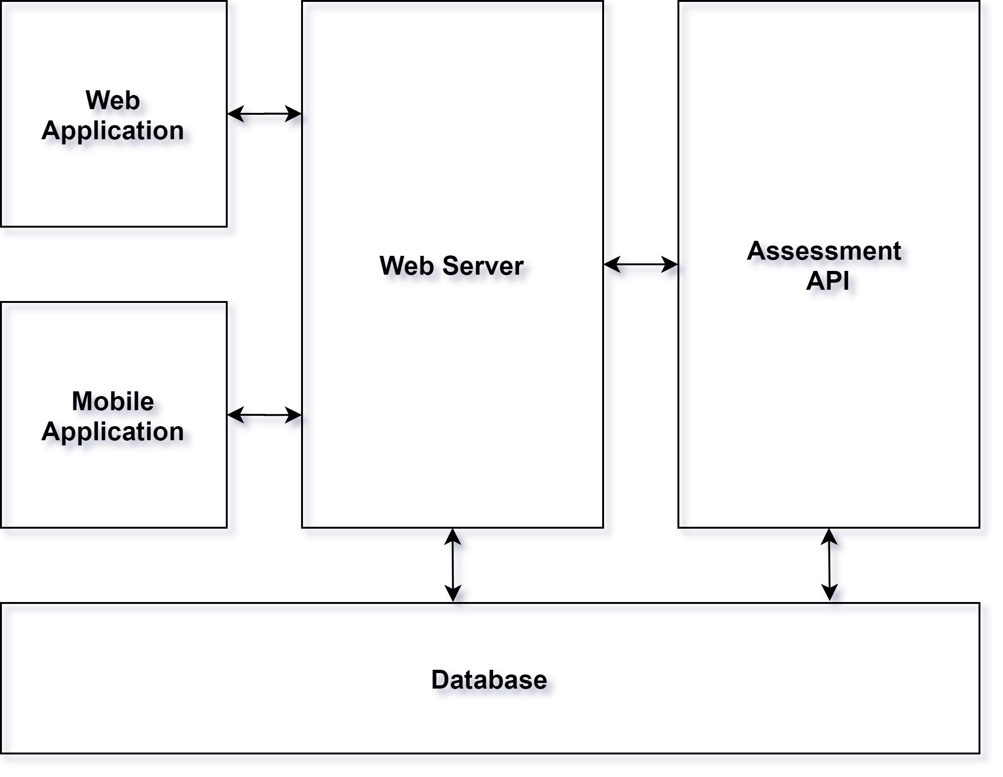

### Use Case Diagram

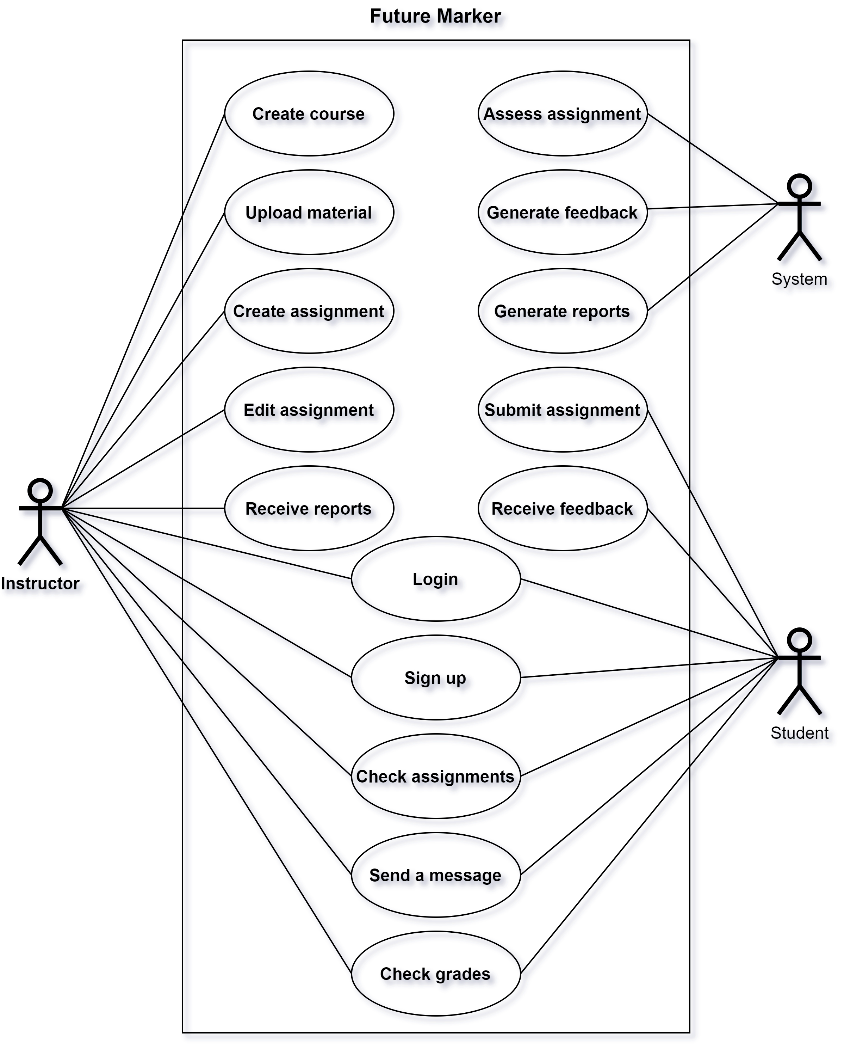

### Class Diagram

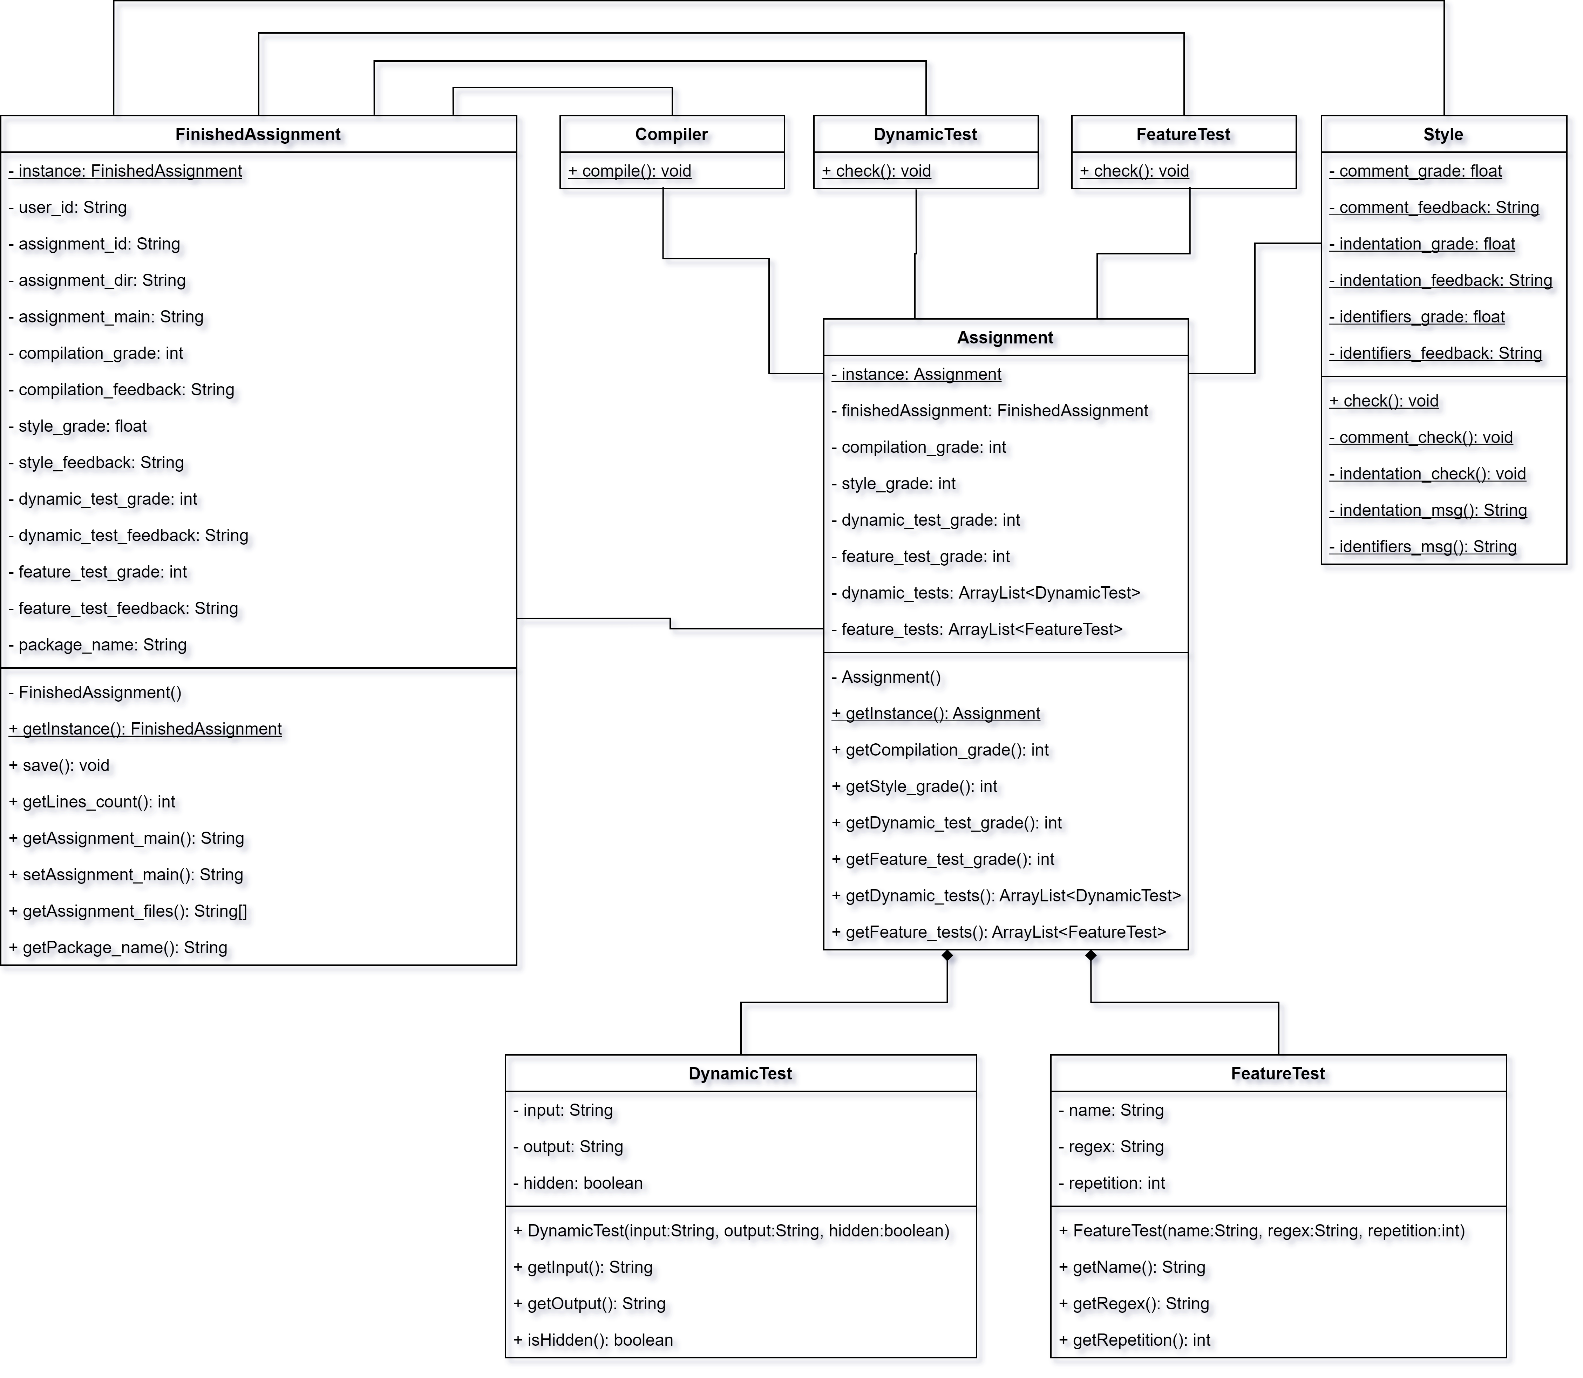

### Design Patterns

1. **MVC**

We are using MVC as a design pattern and we chose to work with Laravel because it is the most suitable platform that will help us using MVC.

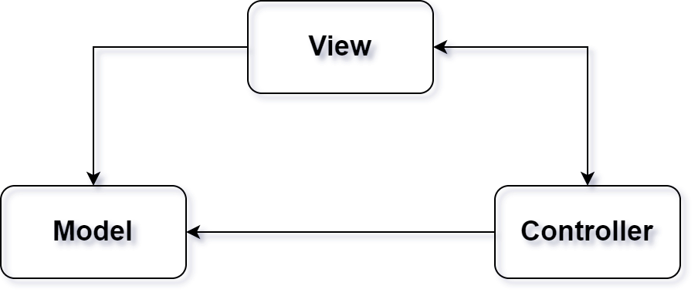

1. **Singleton**

Singleton design is useful when exactly one object is needed to coordinate actions across the system, because of this we decided to use singleton design pattern in our API to restrict the instantiation of a class to one "single" instance in “Assignment” class and “FinishedAssignment” class.

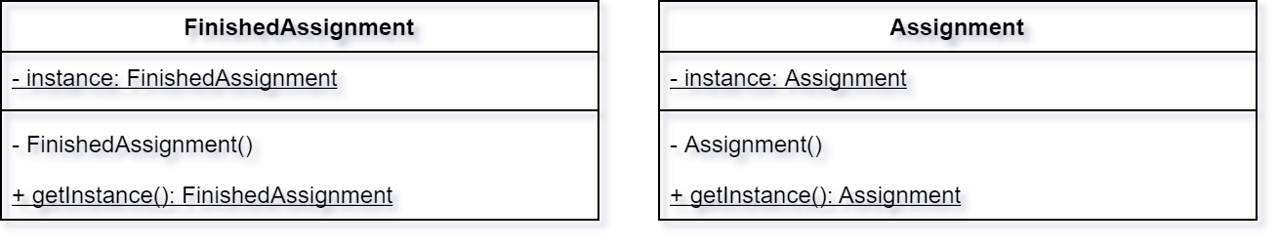

### Sequence Diagrams

User registration

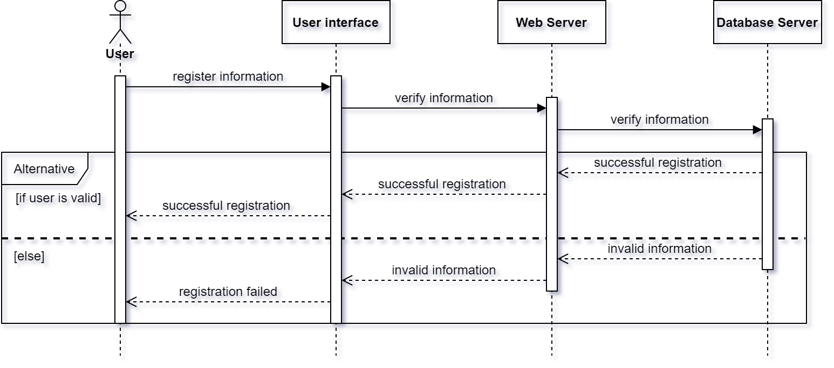

Instructor course creation

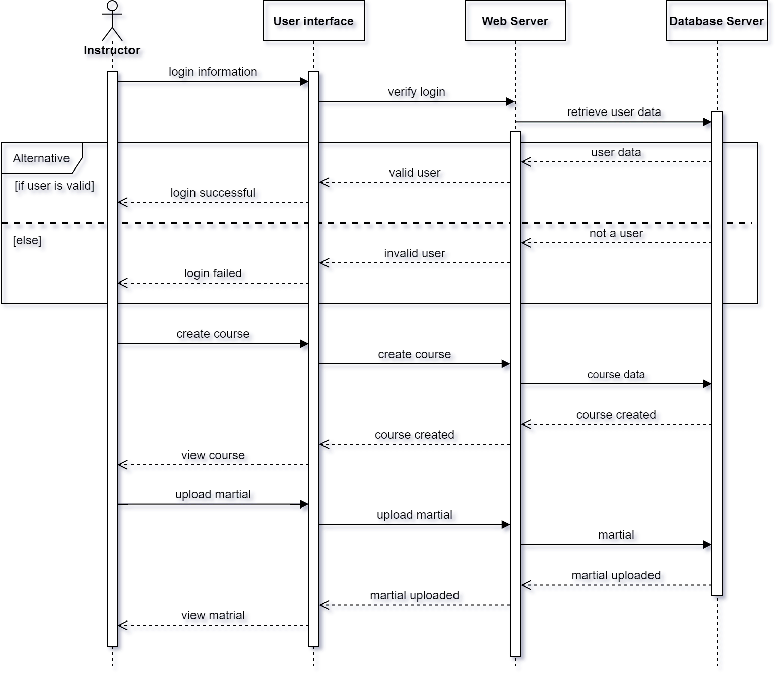

Instructor assignment creation

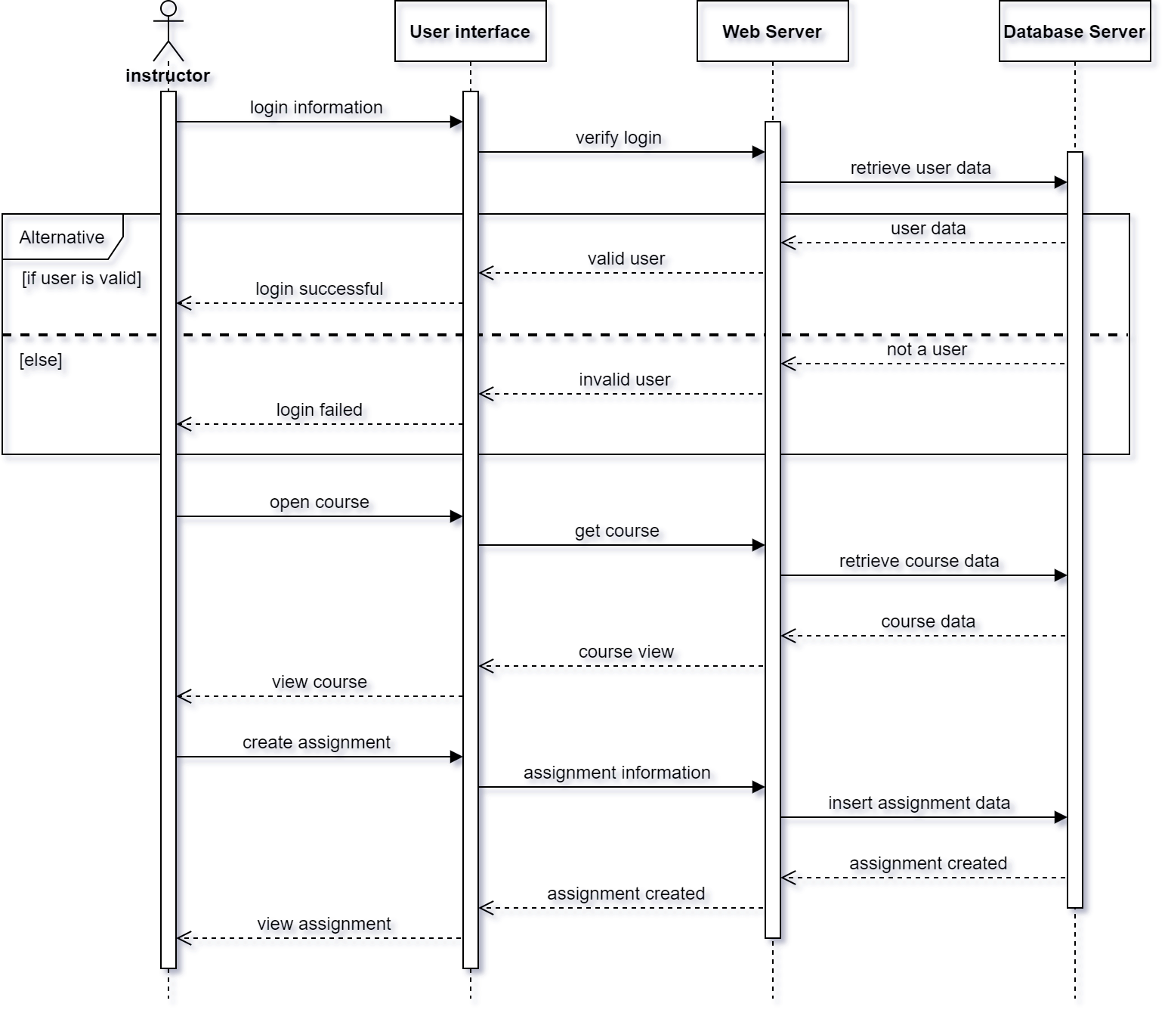

Instructor quiz creation

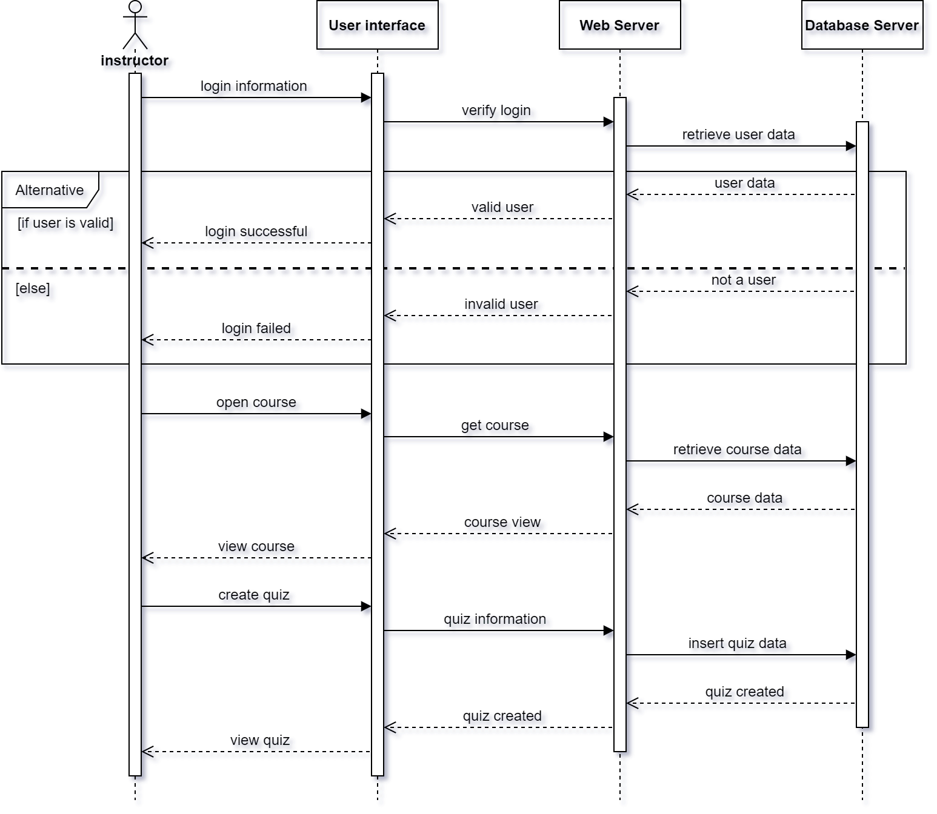

Student joining course

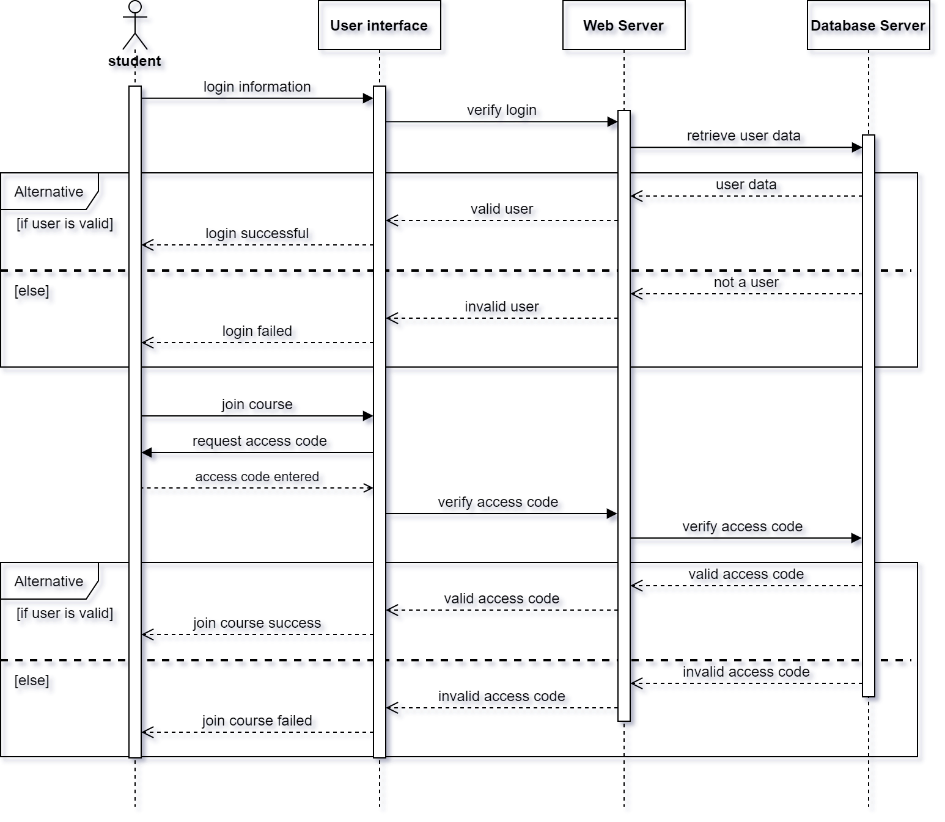

Student assignment submission

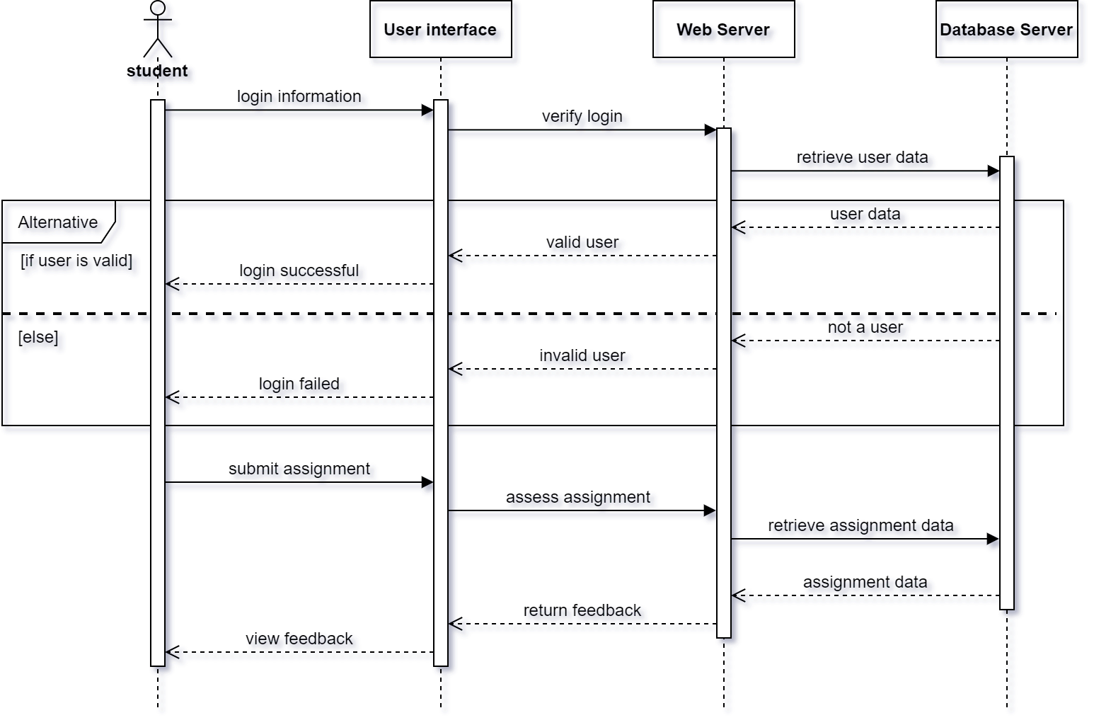

Student quiz answering

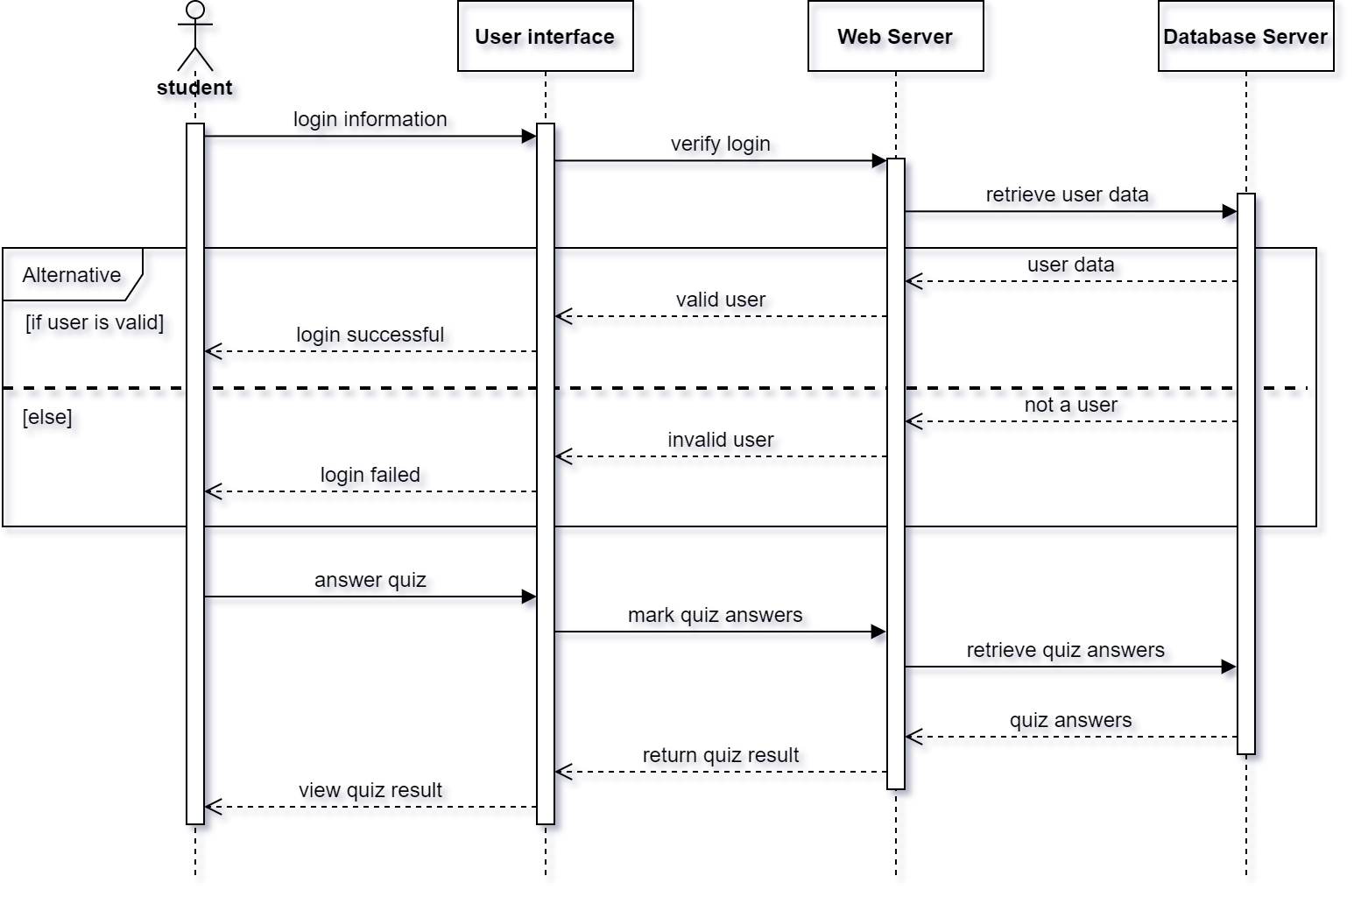

### Database Design (ERD)

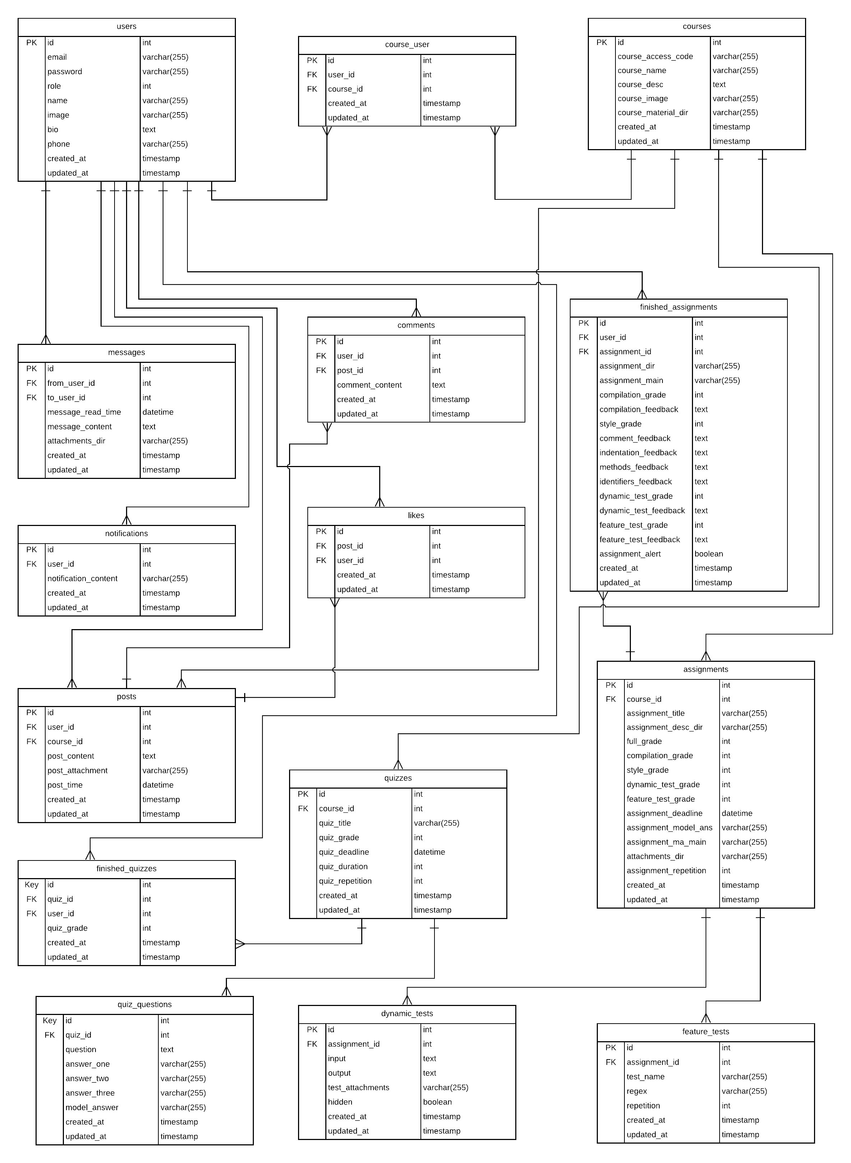

**Storage Structure**

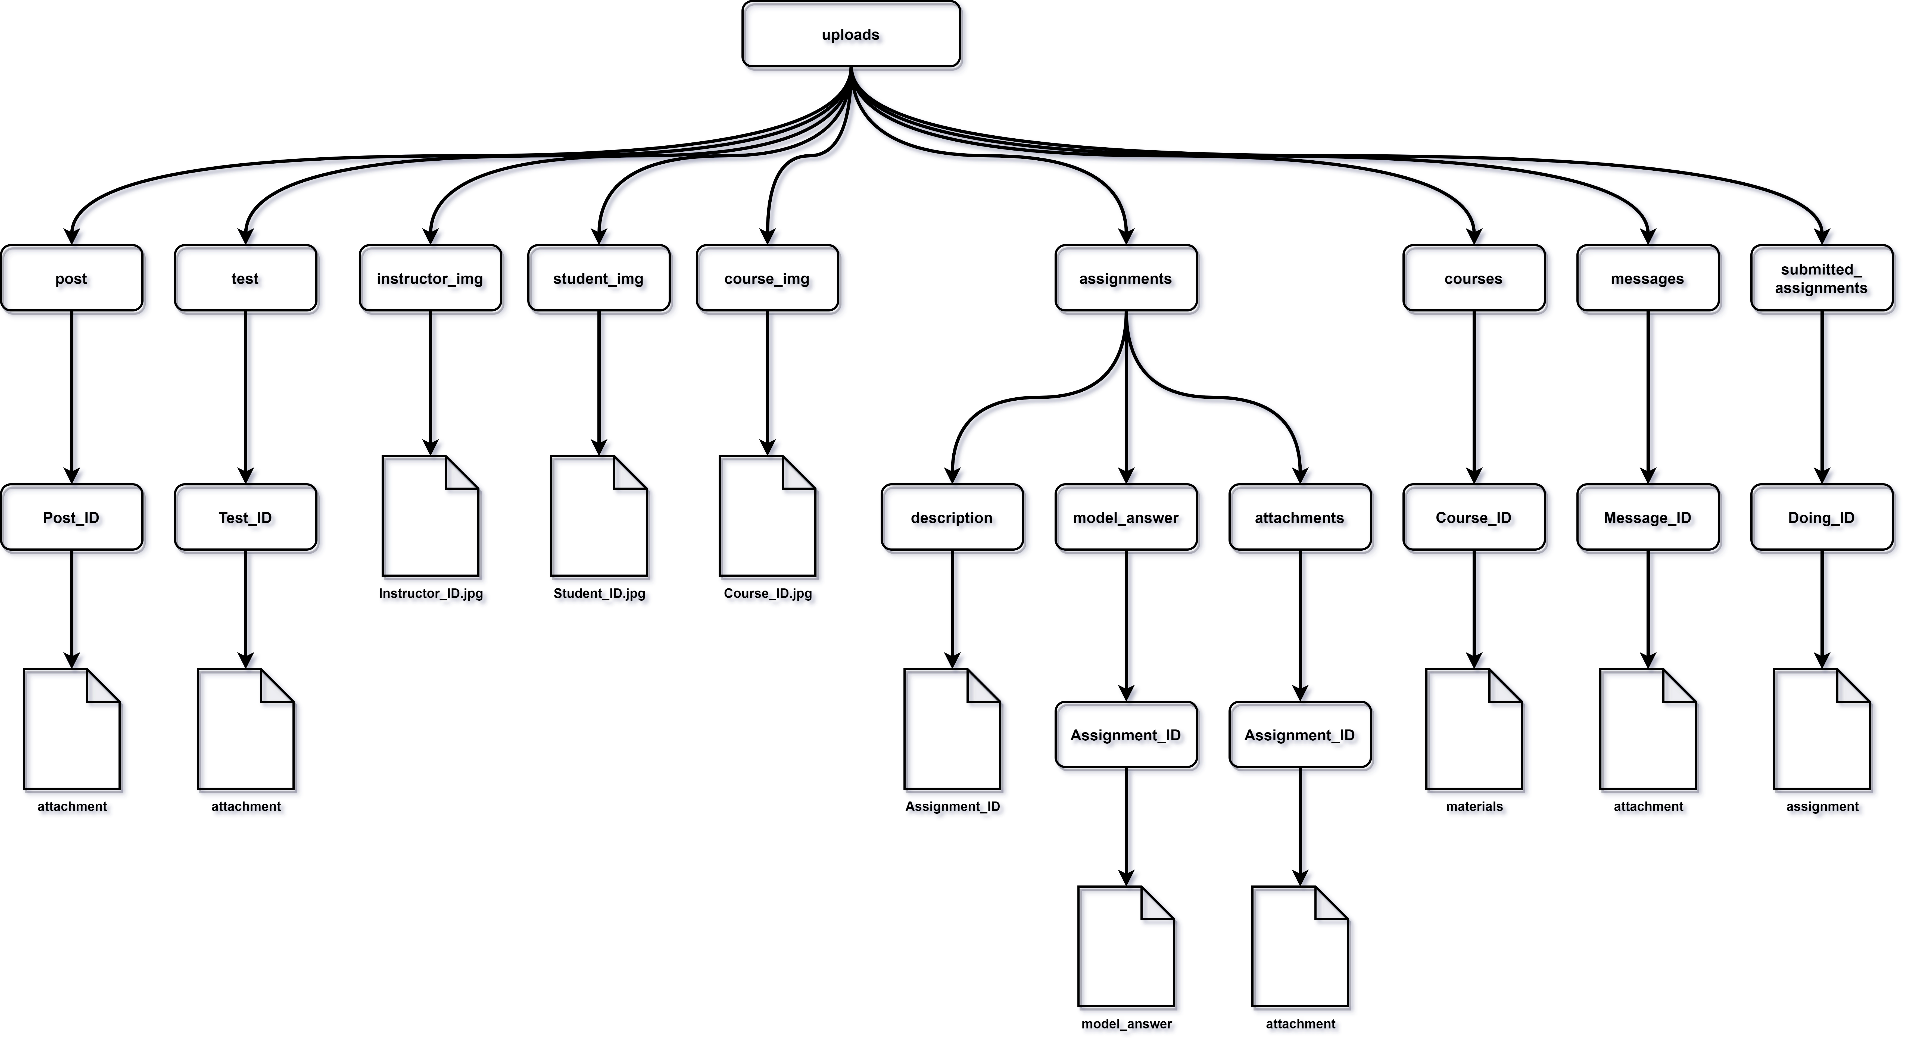

## Used Technologies and tools :

* HTML, CSS, JavaScript
* Bootstrap 4
* Laravel framework
* PHP
* Java
* MYSQL
* Flutter
* GitHub
* Jira
* Digital Ocean cloud

Summary

In this chapter we have discussed our analysis and design for the system, and the diagrams that describe it, we have discussed what tools and technologies we are using, furthermore, we illustrated the functional and non-functional requirements, besides the user and system requirements.

# Chapter 3 Deliverables and Evaluation

**Main points**

* Introduction
* User Manual
* Testing
* Evaluation (User Experiment)
* Summary

## Introduction

In this phase we are showing the project deliverables and how we test our product, besides we are showing the user manual easily to the user so he can use the project and know how to use its features and specification without facing and any problems or constraints, Furthermore, we are representing the user experiment whether on the first demo of Future Marker or on the final output after finishing the product and discussing the result of this experiment and Feedback that we have received.

## User Manual

Here’s the user guide for helping you to access and use Future Marker

Open your Brower and go to futuremarker.com, then create an account by clicking on Register or Join us.



**Instructor’s guide:**

After login this the home page you will see your posts and courses.

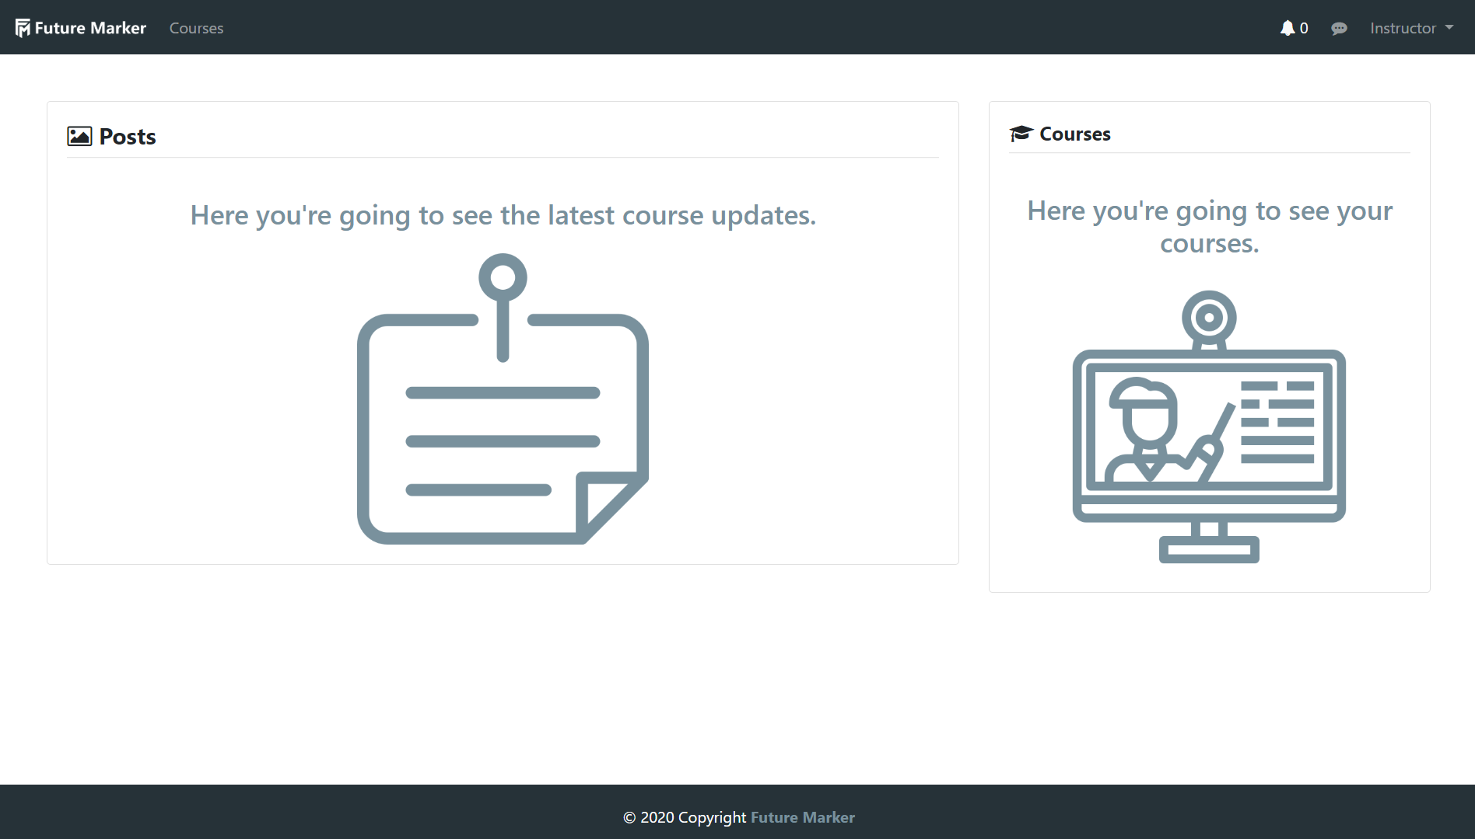

This is the courses page, here you can see your courses and create one.

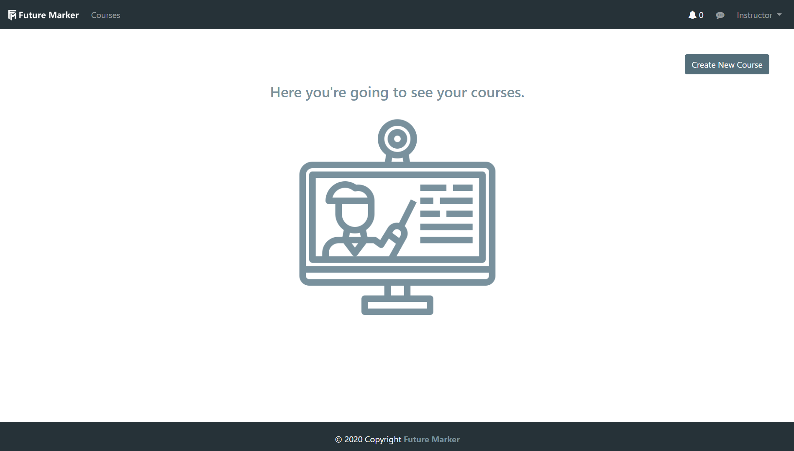

This is your course page, here you can add martial create assignment, create quizzes, create posts, and monitor your students’ grades.

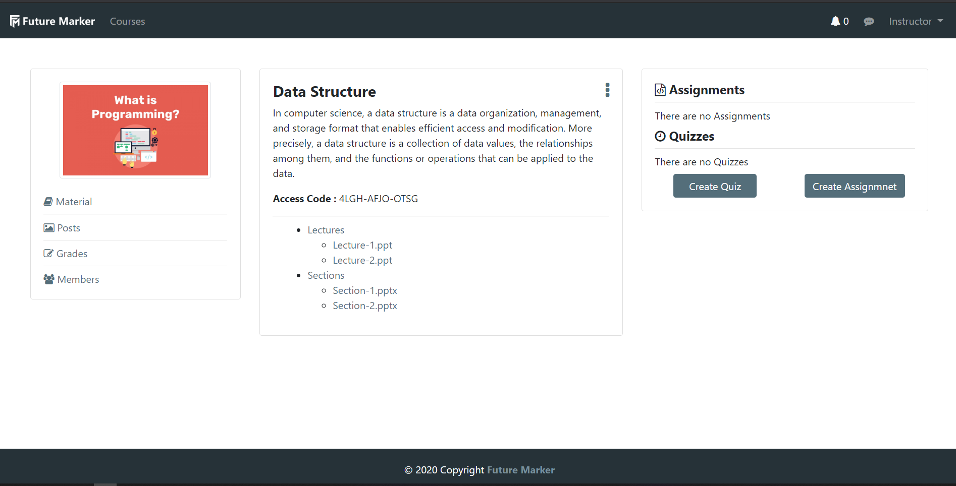

To create assignment you have to determine the deadline, write the assignment description, and determine the grades distribution, furthermore, you can add attachments, in addition to you can use the dynamic testing by entering the inputs and the expected output, also, you can use feature testing to look for any feature in the assignment and its count.

Soraaaaaaaaaaaaaaaaaaaaaaaaaaaaaaaaaaaaaaaaaaaa

Student’s guide

After login this the home page you will see your instructor’s posts and upcoming assignments and quizzes.

Soooooraaaaaaaaaaaaaaa

This is the courses page, here you can see your courses and join one.

sooooraaaaaaaaaaaaaaaaaaa

This is your course page, here you can download material, submit assignments, answer quizzes, see your grades, and know your classmates.

sooooooooooraaaaaaaaaaaaa

## Testing

After finishing implementation of the project we have moved to the testing phases which are two phases before making the user experiment, the first phase is testing the project by our self and make sure that everything in the system and our functions and the API are working correctly, and the result is that we have found some issues and bugs, and this is normal as we were just done the developing stage and this why the testing stage is important, so we have fixed all the issues and bugs ourselves and tested one more time to make sure that everything is working accurately, and to prove the success of this phase we have decided to move to the second phase which is sending test scenarios with the project running on cloud to another team to test it, and as we expected all the test scenarios succeeded.

## Quality assurance will consist of several stages:

* Review of requirements
* Test planning/writing test cases
* Unit testing
* Integration testing
* System testing
* Performance testing
* Security testing
* Cross-browser testing / cross-platform testing
* Updating test cases
* Regression testing

**Test Scenario 1:** Check register functionality  
Open the website, then click on the register button, register form will appear then start to enter the credentials.

|  |  |  |  |  |
| --- | --- | --- | --- | --- |
| Test Case | Test Data | Expected result | Actual Result | Status |
| Ignore selecting role | Name: name  Email:user@gmail.com Password: Password  Confirm password: Password | An error message should appear, and should not register. | An error message should appear, and should not register. | success |
| Enter the wrong format of the email. | Name: name  Email:user.com Password: Password  Confirm password: Password | An error message should appear, and should not register. | An error message should appear, and should not register. | success |
| Enter the wrong format of the password. | Name: name  Email:user@gmail.com Password: 123  Confirm password: 123 | An error message should appear, and should not register. | An error message should appear, and should not register. | success |
| Enter empty email. | Name: name  Email:  Password: Password  Confirm password: Password | An error message should appear, and should not register. | An error message should appear, and should not register. | success |
| Enter an empty name. | Name:  Email: user@gmail.com  Password: Password  Confirm password: Password | An error message should appear, and should not register. | An error message should appear, and should not register. | success |
| Enter an empty password. | Name: name  Email: user@gmail.com  Password:  Confirm password: Password | An error message should appear, and should not register. | An error message should appear, and should not register. | success |
| Enter an empty confirm password. | Name: name  Email: user@gmail.com  Password: Password  Confirm password: | An error message should appear, and should not register. | An error message should appear, and should not register. | success |

**Test Scenario 2:** Check login functionality  
Open the website, then click on the login button, the login form will appear then start to enter the credentials.

|  |  |  |  |  |
| --- | --- | --- | --- | --- |
| Test Case | Test Data | Expected result | Actual Result | Status |
| Enter the wrong format of the email. | Email:user@gmail.com Password: Password | An error message should appear, and should not log in. | An error message should appear, and should not log in. | success |
| Enter a non-existing email and the right password. | Email:user@gmail.com Password: Password | An error message should appear, and should not log in. | An error message should appear, and should not log in. | success |
| Enter the wrong format of the password. | Email: user@gmail.com Password: 123 | An error message should appear, and should not log in. | An error message should appear, and should not log in. | success |
| Enter a non-existing email and the wrong password in the database. | Email: undefined_user@gmail.com Password: Wrong password | An error message should appear, and should not log in | An error message should appear, and should not log in. | success |
| Enter existing email and non-existing password in the database. | Email: user@gmail.com Password: Wrong password | An error message should appear, and should not log in | An error message should appear, and should not log in. | success |
| Enter empty email. | Email:  Password: password | An error message should appear, and should not log in | An error message should appear, and should not log in. | success |
| Enter both fields empty. | Email:  Password: | An error message should appear, and should not log in | An error message should appear, and should not log in. | success |

**Test Scenario 3:** Check edit profile functionality as an instructor.  
Login to the website, then go to profile, then start to edit profile.

|  |  |  |  |  |
| --- | --- | --- | --- | --- |
| Test Case | Test Data | Expected result | Actual Result | Status |
| Upload profile image | Image.png/jpg  Image size < 10 MB | It should edit the profile image. | It should edit the profile image. | success |
| Upload profile image with a big size. | Image size > 10 MB | An error message should appear, and should not edit profile image. | An error message should appear, and should not edit profile image. | success |
| Enter empty Bio. | Bio:  phone:01234567899 | It should edit other fields. | It should edit other fields. | success |
| Enter an empty phone. | Bio: this is bio text  phone: | It should edit other fields. | It should edit other fields. | success |
| Ignore selecting a profile image. | Bio: this is bio text  phone:01234567899 | It should edit other fields. | It should edit other fields. | success |
| Enter wrong format of the phone. | Bio: this is bio text  phone: phone | Error message\ should appear, and should not edit the phone. | Error message\ should appear, and should not edit the phone. | success |

**Test Scenario 4:** Check edit profile functionality as a student.  
Login to the website, then go to profile, then start to edit profile.

|  |  |  |  |  |
| --- | --- | --- | --- | --- |
| Test Case | Test Data | Expected result | Actual Result | Status |
| Upload profile image | Image.png/jpg  Image size < 10 MB | It should edit the profile image. | It should edit the profile image. | success |
| Upload profile image with a big size. | Image size > 10 MB | An error message should appear, and should not edit profile image. | An error message should appear, and should not edit profile image. | success |
| Enter empty Bio. | Bio:  phone:01234567899 | It should edit other fields. | It should edit other fields. | success |
| Enter an empty phone. | Bio: this is bio text  phone: | It should edit other fields. | It should edit other fields. | success |
| Ignore selecting a profile image. | Bio: this is bio text  phone:01234567899 | It should edit other fields. | It should edit other fields. | success |
| Enter wrong format of the phone. | Bio: this is bio text  phone: phone | An error message should appear, and should not edit the phone. | An error message should appear, and should not edit the phone. | success |

**Test Scenario 5:** Check the course creation functionality as an instructor.  
Login to the website then courses page, then click on create course button.

|  |  |  |  |  |
| --- | --- | --- | --- | --- |
| Test Case | Test Data | Expected result | Actual Result | Status |
| Enter empty Course Name | Course Name:  Course Description: that described the course  Course Image: image.jpg | An error message should appear, and should not create | An error message should appear, and should not create | success |
| Enter empty Course Description | Course Name: course name  Course Description:  Course Image: image.jpg | An error message should appear, and should not create | An error message should appear, and should not create | success |
| Enter empty image | Course Name: course name  Course Description: that described the course  Course Image: | An error message should appear, and should not create | An error message should appear, and should not create | success |
| Enter valid data | Course Name: course name  Course Description: that described the course  Course Image: image.jpg/png | It should create a course | It should create a course | success |

**Test Scenario 6:** Check to join course functionality as a student.  
Login to the website then courses page, then click on join course button.

|  |  |  |  |  |
| --- | --- | --- | --- | --- |
| Test Case | Test Data | Expected result | Actual Result | Status |
| Enter empty Access Code | Access Code : | An error message should appear, and should not join | An error message should appear, and should not join | success |
| Enter invalid Access Code | Access Code: invalid Access code | An error message should appear, and should not join | An error message should appear, and should not join | success |
| Enter valid Access Code | Access Code : Valid access code (Ex: xxxx-xxxx-xxxx) | It should join the course | It should join the course | success |

**Test Scenario 7:** Check to create folder functionality as an instructor.  
Login to the website, then create a course, then click on create folder button from three points.

|  |  |  |  |  |
| --- | --- | --- | --- | --- |
| Test Case | Test Data | Expected result | Actual Result | Status |
| Enter empty Folder name | Folder Name:  Choose File: image.jpg | An error message should appear, and should not create | An error message should appear, and should not create | success |
| Enter existing Folder name | Folder Name: existing name  Choose File: file.pdf | It should upload a file for an existing folder and should not create another one | It should upload a file for an existing folder and should not create another one | success |
| Enter empty upload file | Folder Name: folder name  Choose File: | It should create an empty folder | It should create an empty folder | success |
| Upload file into a new folder | Folder Name: folder name  Choose File: file.pdf | It should create a folder and upload a file into it | It should create a folder and upload a file into it | success |

**Test Scenario 8:** Check upload folder functionality as an instructor.  
Login to the website, then create a course, then create a folder, then click on “upload file” from three points.

|  |  |  |  |  |
| --- | --- | --- | --- | --- |
| Test Case | Test Data | Expected result | Actual Result | Status |
| No select folder | Select Folder : - Select Folder –  Choose File: file.pdf | An error message should appear, and should you select folder | An error message should appear, and should you select folder | success |
| Enter empty data | Folder Name:  Choose File: | An error message should appear, and should not upload file | An error message should appear, and should not upload file | success |
| Enter empty upload file | Folder Name: folder name  Choose File: | An error message should appear, and should not upload file | An error message should appear, and should not upload file | success |
| Upload file into a folder | Folder Name: folder name  Choose File:file.pdf  File size < 40 MB | It should upload a file into selection folder | It should upload a file into selection folder | success |
| Upload file with a big size. | Folder Name:folder name  Choose File:file.pdf  File size > 40 MB | An error message should appear, and should not upload file | An error message should appear, and should not upload file | success |

**Test Scenario 9:** Check post functionality as an instructor.  
Login to the website, then create a course, then click on posts.

|  |  |  |  |  |
| --- | --- | --- | --- | --- |
| Test Case | Test Data | Expected result | Actual Result | Status |
| Empty post | Description:  Upload Attachment: | It should not post | It should not post | success |
| Enter empty description | Description:  Upload Attachment: image.jpg/png | An error message should appear, and should not post | An error message should appear, and should not post | success |
| Enter empty upload attachment | Description: type description here  Upload Attachment: | It should post without file | It should post without file | success |
| Upload attachment | Folder Name:folder name  Choose File:file.pdf  File size < 40 MB | It should post and upload an attachment with post | It should post and upload an attachment with post | success |
| Upload file with a big size. | Folder Name:folder name  Choose File:file.pdf  File size > 40 MB | An error message should appear, and should not post and not upload attachment into it | An error message should appear, and should not post and not upload attachment into it | success |

**Test Scenario 10:** Check post functionality as a student.  
Login to the website, then join the course, then click on posts.

|  |  |  |  |  |
| --- | --- | --- | --- | --- |
| Test Case | Test Data | Expected result | Actual Result | Status |
| Check posts | None | It should view the posts from the instructor | It should view the posts from the instructor | success |
| Download attachments | Click on attachment in a post | It should download automatically | It should download automatically | success |

**Test Scenario 11:** Check comment functionality as an instructor.  
Login to the website, then create a course, then create a post, the type comment.

|  |  |  |  |  |
| --- | --- | --- | --- | --- |
| Test Case | Test Data | Expected result | Actual Result | Status |
| Enter empty comment | comment: | An error message should appear, and should not post the comment | An error message should appear, and should not post the comment | success |
| Enter comment | Comment: comment on a post | It should post the comment | It should post the comment | success |

**Test Scenario 12:** Check comment functionality as a student.  
Login to the website, then join a course, then type comment.

|  |  |  |  |  |
| --- | --- | --- | --- | --- |
| Test Case | Test Data | Expected result | Actual Result | Status |
| Enter empty comment | comment: | An error message should appear, and should not post the comment | An error message should appear, and should not post the comment | success |
| Enter comment | Comment: comment on a post | It should post the comment | It should post the comment | success |

**Test Scenario 13:** Check quiz functionality as an instructor.  
Login to the website, then create a course, then click on create quiz button

|  |  |  |  |  |
| --- | --- | --- | --- | --- |
| Test Case | Test Data | Expected result | Actual Result | Status |
| Enter empty data in any field | Deadline:  Title:  Duration in minutes:  Permissible Attempts:  Question:  Answer1:  Answer2:  Answer3:  Answer4:  Correct answer: | An error message should appear, and should not create a quiz | An error message should appear, and should not create a quiz | success |
| Enter valid data | Deadline:25/10/2020  Title: quiz  Duration in minutes: 5  Permissible Attempts: 4  Question:there is a question  Answer1:answer1  Answer2:answer2  Answer3:answer3  Answer4:answer4  Correct answer: Answer 1,2,3,4 | It should create a quiz | It should create a quiz | success |
| Enter negative number in Duration | Deadline:25/10/2020  Title: quiz  Duration in minutes: -5  Permissible Attempts: 4  Question:there is a question  Answer1:answer1  Answer2:answer2  Answer3:answer3  Answer4:answer4  Correct answer: Answer 1,2,3,4 | An error message should appear, and should not create a quiz | An error message should appear, and should not create a quiz | success |
| Enter negative number in Permissible Attempts | Deadline:25/10/2020  Title: quiz  Duration in minutes: 5  Permissible Attempts: -4  Question:there is a question  Answer1:answer1  Answer2:answer2  Answer3:answer3  Answer4:answer4  Correct answer: Answer 1,2,3,4 | An error message should appear, and should not create a quiz | An error message should appear, and should not create a quiz | success |

**Test Scenario 14:** Check quiz functionality as a student.  
Login to the website, then join a course, then go to a quiz, then click on start quiz.

|  |  |  |  |  |
| --- | --- | --- | --- | --- |
| Test Case | Test Data | Expected result | Actual Result | Status |
| Not answer for any question | No select any answers | It should deduct the degree of the question | It should deduct the degree of the question | success |
| Submit with the right answer | Select correct answer | It should put give the full grade of these question | It should put give the full grade of these question | success |
| Submit with wrong answer | Select wrong answer | It should put give 0 grade of these question | It should put give 0 grade of these question | success |
| Submit more than permissible attempts | Number of submissions > permissible attempts | It should disable start quiz button after permissible attempts | It should disable start quiz button after permissible attempts | success |
| Don’t submit before the timeout | Wait for  remaining time:0h 0m 0s | It should submit the answers automatically | It should submit the answers automatically | success |

**Test Scenario 15:** Check assignment functionality as an instructor.  
Login to the website, then create a course, then click on create an assignment.

|  |  |  |  |  |
| --- | --- | --- | --- | --- |
| Test Case | Test Data | Expected result | Actual Result | Status |
| Enter a negative number in Permissible Attempts | Permissible Attempts: -5  (And fill all valid data) | An error message should appear, and should not create an assignment | An error message should appear, and should not create an assignment | success |
| Enter grades percentage <> 100% | Compilation + Style + Dynamic test + feature test <> 100%  (And fill all valid data) | An error message should appear, and should not create an assignment | An error message should appear, and should not create an assignment | success |
| Upload file with a big size. | Upload attactment:file.pdf  File size > 40 MB  (And fill all valid data) | An error message should appear, and should not create an assignment | An error message should appear, and should not create an assignment | success |
| Enter a dynamic test with empty data | Dynamic test  Input :  Output:  (And fill all valid data) | An error message should appear, and should not create an assignment | An error message should appear, and should not create an assignment | success |
| Enter negative repetition count in feature testing | Feature Testing  Repetition count: -5  (And fill all valid data) | An error message should appear, and should not create an assignment | An error message should appear, and should not create an assignment | success |
| Enter valid data for create assignment | fill all fields with valid data | It should create an assignment and push back to the course page with a success message | It should create an assignment and push back to the course page with a success message | success |

**Test Scenario 16:** Check assignment functionality as a student.  
Login to the website, then join a course, then click on an assignment.

|  |  |  |  |  |
| --- | --- | --- | --- | --- |
| Test Case | Test Data | Expected result | Actual Result | Status |
| Submit file with a wrong extension | Assignments files: fille.pdf | An error message should appear, and should not submit an assignment | An error message should appear, and should not submit an assignment | success |
| Submit java file | Assignments files: main.java | It should submit and mark | It should submit and mark | success |
| Submit multiple java files | Assignments Files: “code 1.java” ”code 2.java” “main.java” (3 files ) | It should submit and mark | It should submit and mark | success |
| Upload file with a big size. | Assignments file: main.java  File size > 40 MB | An error message should appear, and should not submit an assignment | An error message should appear, and should not submit an assignment | success |
| Submit more than permissible attempts | Number of submissions > permissible attempts | It should disable submit assignment automatically after permissible attempts number | It should disable submit assignment automatically after permissible attempts number | success |

## Evaluation (User experiments)

## First Experiment

After finishing three main functions from our project which are checking comments in the code, Code indentation and identifiers name and length, we had decided that we have to test it with second year computer science students at Future Academy in a specific programming course which is CSC211 - Programming Language (2).

This experiment consisted of two submissions, after first submission we provide them with grade report showing them how the program evaluates their comments, indentation, identifiers, and after the students see their grade report for each java class, they try to modify and edit their code again for the second submission.

The following graphs shows the improvements in grades for some teams in each section (Comments, Indentation, and Identifiers) in the first and the second submission.

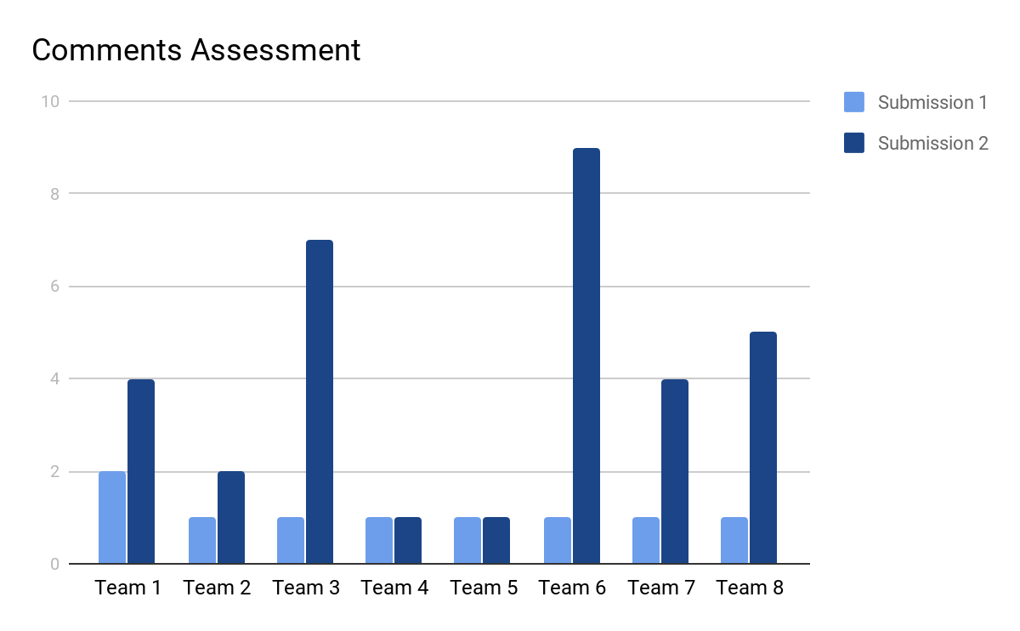

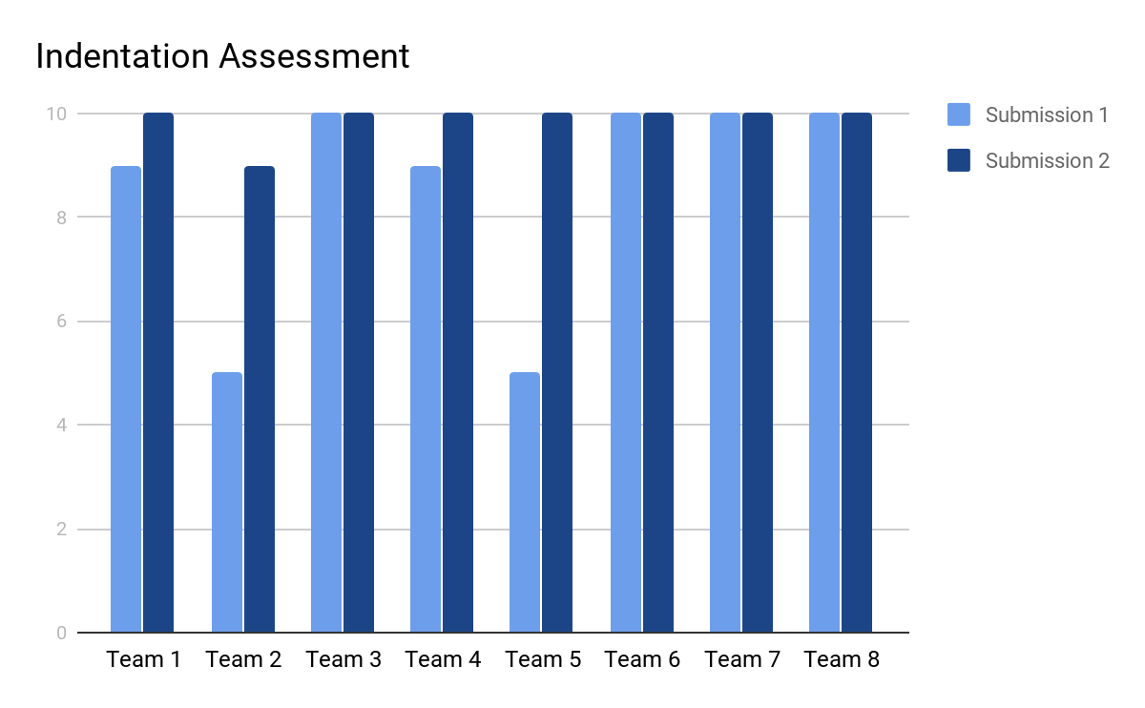

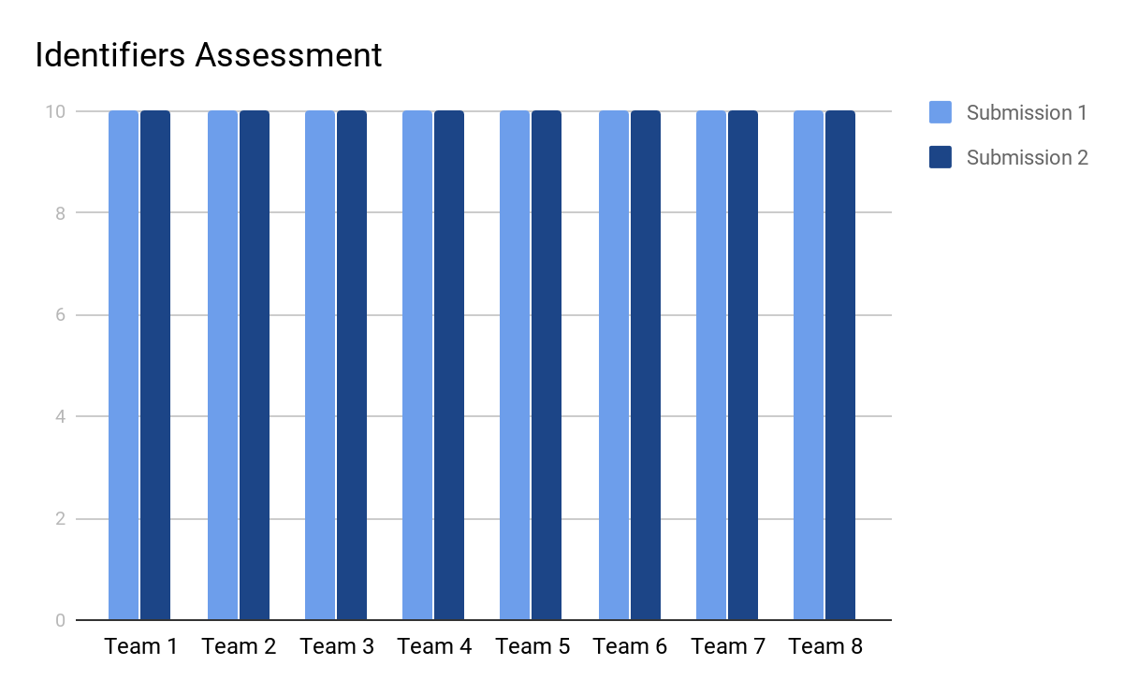

In addition to, we asked them to fill online survey we have created it to see if they are satisfied of this experiment and what is their opinion about our project, and the feedback was positive and encouraging.

Summary

In this part we have discussed how we tested our projects and what are the results of this testing and how the received feedback from the users helped us to maintain and fix the bugs, In addition to we are showing the User Manual for Future Marker that shows the user how to use it as a student or instructor, Furthermore, we have discussed our evaluation for the user experiments.

## Second Experiment

Here in this experiment we have finished the developing and testing stages of the system and it became already free and available for everyone as you can reach it on <futuremarker.com>, so we have decided to test it with the end-users as we have created an instructor account and choose a random sample of computer science students different levels of education, we have created a course and uploaded material in it, besides, we have created two java assignments, and we have also created an online quiz, and finally we gave them the course’s access code and asked them to sign up as a student and join the course to navigate the web application and try to solve the assignments and upload it to receive the grades and feedbacks, furthermore, solving the online quiz to get its mark.

As project owners, we have created a user satisfaction questionnaire for the students who tested the web application to ask them several questions that will get us to know their opinion on the whole system after they got interact with it and used its functions.

And here’s the questionnaire result:

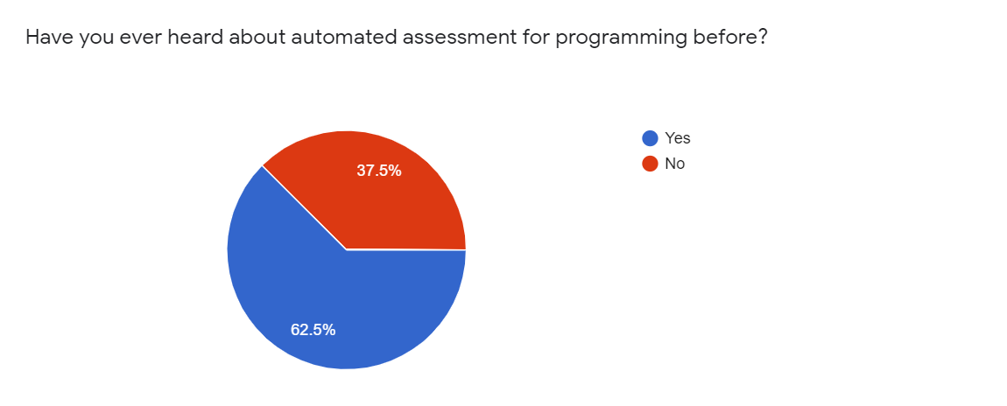

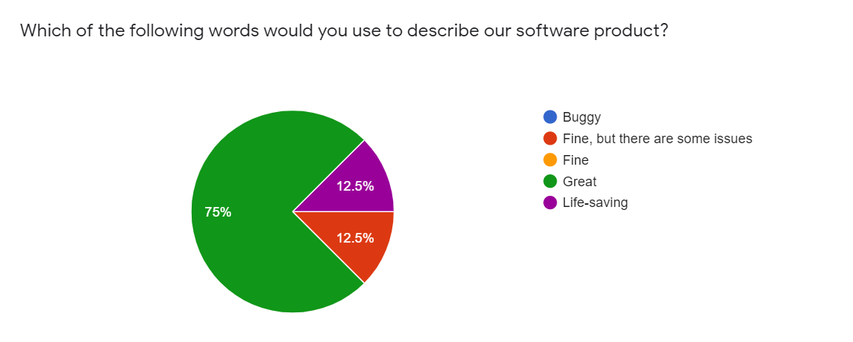

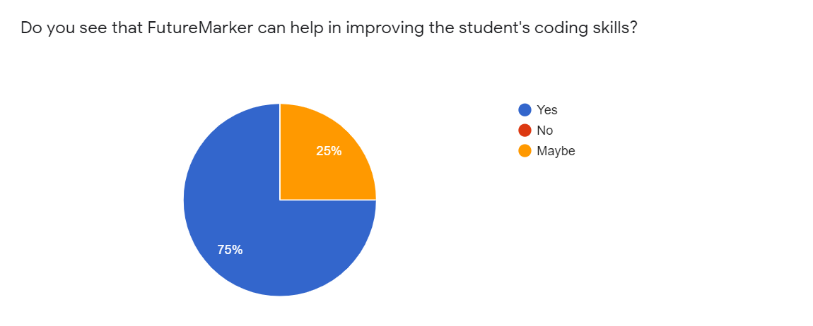

## 

## 

## 

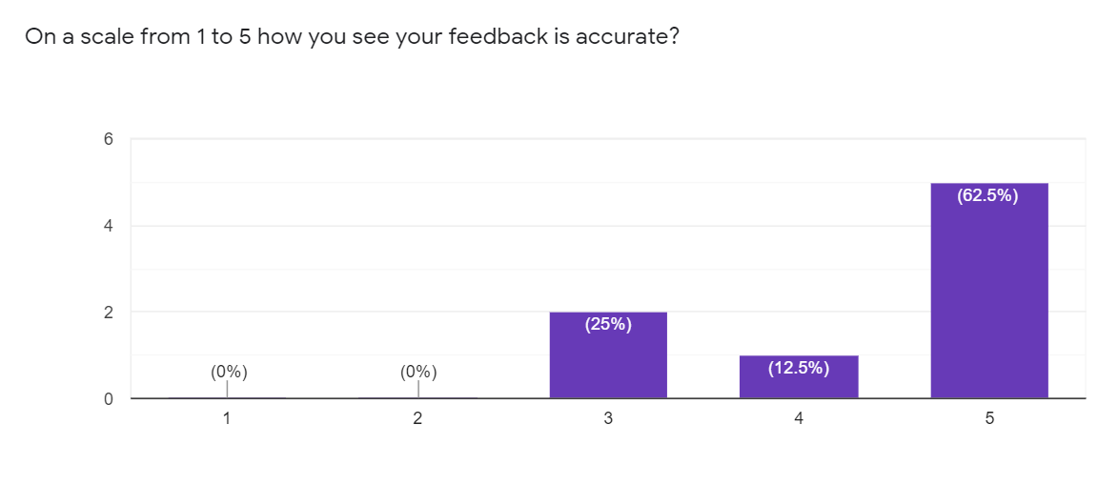

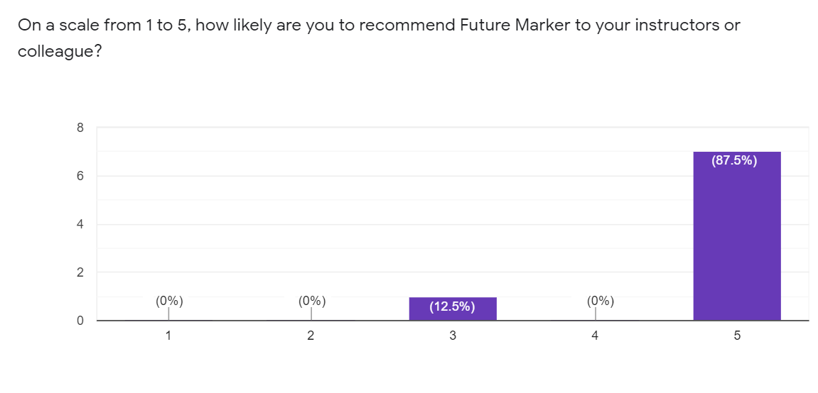

# Chapter 4 Discussion and Conclusion

**Main points**

* Introduction
* Main findings

## Introduction

Here in this chapter, we have reached the last phase of the project after we have finished the previous phases as we have discussed in them the main problem that we are solving it and how we have solved it and what methodology we have followed, and what tools we have used, besides the deliverables of the project, also we have explained the functional and non-functional requirements, besides the user requirements, furthermore, we have shown the diagrams that clarify our system, we have also presented our testing and user experiment, and finally, here we are going to discuss the main findings that we have found and reached and why our project is very important for the educational schools and universities and what is we are planning to do regards the future improvements and recommendations for Future Marker.



Figure 1:

## Main Findings

### Why is this project important?

There is no doubt that the automation and artificial intelligence are making our life easier and saving our valuable time, all universities and schools today are willing to have an Learning management system not just for facilitating their work and deliver the material and lessons for the students easily, also it becomes necessary for them today to use it as they we have seen in the lockdown that we faced because of the epidemic of Coronavirus (COVID-19), so **Future Marker** allows the instructors to communicate with students and deliver the course materials for them in addition to providing them with and automation assessments system that automatically mark the programming assignments that submitted by the students and giving them a grading report, furthermore **Future Marker** provides online quiz system so the universities and schools can easily examine their students online from home.

### Practical Implementations

We will discuss who will use our application from the user perspective, we will be having two main users which are:

* Instructor
* Student

First the instructor, The instructor will be using the application because of its advantages that will help him innovate new way of learning and connecting with the his students, first of all he will be able to have social experience throw making posts which the student who enroll in his course or follow him can interact with, also he can create courses, upload material, assign grades, assignments and make quizzes, and with the integration of the auto marking in the system the students can get there grades immediately after upload his answers which saves afford and time.

Next the Student which will benefit from the platform which collect all the courses material, assignments, grades in one place which he can access from anywhere, and with the instant feedback on the assignments they will have a whole new experience because they can learn more from their mistakes from the detailed report of the assignment grading.

## 

## Future Recommendation

We have made a great work in this project, as we have spent too much time and made a great effort to build this smart learning management system, we still have more goals to improve it in the future first of all we going to contract with a specialized marketing agency to help us in marketing and spreading Future Marker to the educational organizations, this is for the marketing plans, on the other hand, we have also a development plan as we can add more features in the system such as making the automated assessment works on more programming languages such as Python, C++, JavaScript, and C#, furthermore, it will be very useful to provide the system with one of the most important features nowadays in the distance education, which is the option of online meetings, also we are going to add more features for the mobile application that make the user more satisfied, moreover, we are aspiring to make Future Marker able to mark and evaluate the essay assignments besides the software diagrams, Finally it will be useful to create admin dashboard which makes the admins able to check and montorize the system performance and how it is doing statistically.

## Conclusion Summary

Lorem ipsum dolor sit amet, consectetuer adipiscing elit.

# References

|  |  |
| --- | --- |
| [1] | D. Gooblar, "news," 4 January 2017. [Online]. Available: https://chroniclevitae.com/news/1656-how-can-we-minimize-grade-challenges. |
| [2] | T. A. Khan, "buyer-blog/how-technology-improves-education," 28 march 2019. [Online]. Available: https://www.trustradius.com/buyer-blog/how-technology-improves-education. |
| [3] | V. A. Shashank Srikant, "A System to Grade Computer Programming Skills using Machine Learning," 2014. |
| [4] | HOLLINGSWORTH, "The morphology of intersexes in Drosophila subobscura," *The Journal of experimental zoology,* vol. 143, 1960. |
| [5] | E. a. H. C. a. S. P. a. T. A. Foxley, "The CourseMaster Automated Assessment System - a next generation Ceilidh," 2001. |
| [6] | N. G. R. B. Mike Joy, "The boss online submission and assessment system," 2005. |
| [7] | S. S. Peter Brusilovsky, "Individualized exercises for self-assessment of programming knowledge: An evaluation of QuizPACK," September 2005. |
| [8] | T. R. Tuukka Ahoniemi, "aloha title : a grading tool for semi-automatic assessment of mass programming courses," February 2006. |
| [9] | O. L. A. N. W. C. Jacques Philippe Sauvé, "EasyAccept: a tool to easily create, run and drive development with automated acceptance tests," May 2006. |
| [10] | T.-L. W. Fu Lee Wang, "Designing Programming Exercises with Computer Assisted Instruction," August 2008. |
| [11] | H. Suleman, "Automatic marking with Sakai," 2008. |
| [12] | M. A. P.-Q. Stephen H. Edwards, "Web-CAT: automatically grading programming assignments," September 2008. |
| [13] | T. Verhoeff, "Programming Task Packages: Peach Exchange Format," 2008. |
| [14] | J. C. M. E. F. B. Draylson Micael de Souza, "ProgTest: An environment for the submission and evaluation of programming assignments based on testing activities," 2011. |
| [15] | S. a. A. V. Srikant, "A system to grade computer programming skills using machine learning," 2014. |
| [16] | Z. T. P. H. Robert Meersman, On the Move to Meaningful Internet Systems: OTM 2008 Workshops, 2008. |
| [17] | Z. Tari, On the Move to Meaningful Internet Systems: OTM 2008 Workshops, 2008. |